**Trip With the Flow – Ai Powered Travel Buddy**

Nate Seon

seonnate@cityuniversity.edu

Ayush Kumar Gupta

[guptaayushkumar@cityuniversity.edu](mailto:guptaayushkumar@cityuniversity.edu)

En-Xiang Lin

linenxiang@cityuniversity.edu

School of Technology & Computing

City University of Seattle

Seattle, WA 98121, USA

**Abstract**

This paper presents the development of an AI-powered travel assistant designed to automate and personalize trip planning based on user-defined parameters. By entering a destination and duration, users receive a comprehensive itinerary featuring curated dining options, sightseeing locations, hidden attractions, and relevant multimedia content. The system leverages advanced AI capabilities via the Gemini API and integrates multiple third-party services, including Google Places and YouTube Data APIs. Implemented using the MERN stack and React Native, the application streamlines the planning process while enhancing the overall travel experience. Emphasis is placed on privacy-preserving data handling, scalability, and extensibility for future enhancements.

**Keywords:** Travel Recommendation System, AI Travel Assistant, MERN Stack, React Native Development, Gemini API, Google Calendar, Google Places API, YouTube Data API

1. **INTRODUCTION**

Recent studies highlight the effectiveness of AI in optimizing travel planning. The Gemini API, as utilized in our system, reflects modern trends in generative AI to provide multimodal and personalized content (Google AI, 2024).

These advancements emphasize the transition from static travel planning platforms to adaptive, conversational agents, aligning with our implementation strategy using Gemini for dynamic content creation and context-aware recommendations.

Travel planning can be overwhelming, especially when navigating unfamiliar destinations, managing time, and filtering through excessive online content. Traditional travel apps require users to manually choose attractions and build schedules. This project aims to automate and enhance the experience through a conversational AI agent that functions as a personalized travel agent.

The proposed system is a cross-platform application developed using the MERN stack with React Native. It combines AI-generated itineraries with curated online resources to deliver an end-to-end travel guide experience. With this, users can enjoy more and plan less.

1. **OBJECTIVES**

* To build an intelligent travel planner that needs minimal user input.
* To generate structured, day-wise itineraries using AI based on destination and trip length.
* To recommend popular restaurants, attractions, and local experiences.
* To fetch and suggest relevant YouTube videos for better pre-trip insights.
* To optionally integrate maps and calendar services for reminders and directions.

1. **Literature Review**

The integration of artificial intelligence into travel planning has seen rapid innovation in recent years. Traditional itinerary planning systems relied heavily on static data and rigid scheduling interfaces. Modern systems, as described by Manideep et al. (2024) and Google AI (2024), employ generative AI to provide dynamic, multimodal experiences that adapt to individual user preferences and real-time data sources.

Google’s Gemini API, a central technology in this project, supports text, image, audio, and code-based inputs, offering nuanced itinerary creation through advanced reasoning and contextual awareness. Unlike conventional chatbots or travel apps, Gemini facilitates multimodal interactions and offers secure, privacy-preserving user data handling—a critical evolution noted in both the Gemini API documentation and industry evaluations (Google AI, 2024).

Additionally, similar systems like the AI itinerary generator explored by the IRJET (2024) emphasize the importance of YouTube content recommendations, restaurant/landmark discovery via Google Places API, and interactive feedback loops. Our work builds on these foundations while contributing novel features such as encrypted preference hashing, reinforcement learning loops, and group travel conflict resolution.

These advancements reflect the growing trend of AI-powered digital agents moving from simple suggestive systems to full-scale autonomous planning companions.

1. **SYSTEM ARCHITECTURE**

**1. Frontend (React Native)**

* Allows users to input destination, duration, and preferences.
* Displays itinerary, maps, and video recommendations.
* Uses Expo for cross-platform support.

**2. Backend (Express.js + MongoDB)**

* Stores user preferences and saves trips.
* Manages API calls and handles communication with AI and third-party services.

**3. AI Integration (Gemini API)**

* Parses user input and generates custom itineraries.
* Extract destination themes and categorize activities using Google Gemini.

**4. External APIs**

* **Google Places API**: Fetches local restaurants, landmarks, and attractions.
* **YouTube Data API**: Recommends top-rated travel content for the destination.

5**.** Secure Personalization & Conflict

Resolution with Gemini API:

We personalize each itinerary in a privacy-preserving, secure manner using Google’s Gemini API and an encrypted user-profile store internally. When a user provides their preferences (e.g., “adventure,” “budget,” “nature”), those are hashed and saved into MongoDB using standard AES-256 encryption in real-time. At request time, we send just an opaque, unique user ID and hashed preference profile to the Gemini endpoint—never raw user information. Gemini’s zero-knowledge system provides for all AI prompt processing and option ranking to be done inside Google’s secure enclave; we get just a ranked list of activities, never intermediate user embeddings or underlying user text

* In cases where the user’s stated preferences conflict (for example, “luxury” vs “backpacking”) or are incomplete, our middleware runs a simple rules engine:
* Preference weighting: We assign each category a weight based on how many times the user has selected it.
* Fallback logic: If two categories have equal weight, we default to “balanced” itineraries (mixing low-cost and high-end options).
* User feedback loop: On the summary screen (Figure 7), users can upvote or remove specific suggestions; we feed those signals back to Gemini as “reinforcement feedback” to gradually refine future itineraries.

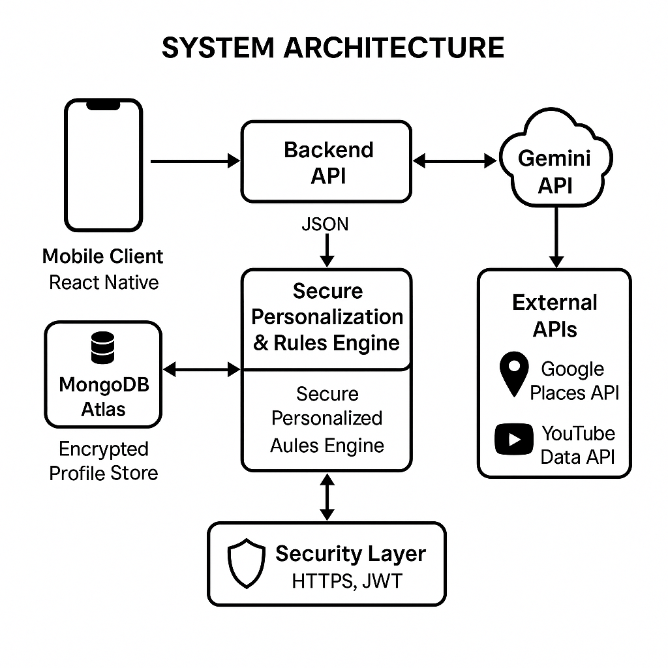Figure 1: System architecture

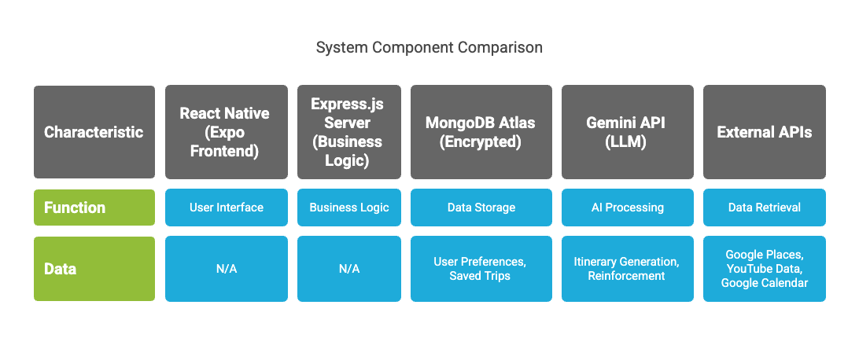Figure 2: System component comparison

6. Gemini vs other models

|  |  |  |
| --- | --- | --- |
| **Feature / Model** | **Gemini 2.5 (Pro)** | **GPT-4 / GPT-4o (“Omni”)** |
| **Context-window size** | 1 million tokens (→2 M soon) | 128 K tokens |
| **Reasoning & chain-of-thought** | Ultramodern logical reasoning, multi-step problem solving | Excellent, but can lose track over longer chains |
| **Code generation** | Can generate complete applications (e.g., an endless runner game) from a single prompt | Very capable, extensive plugin ecosystem |
| **Multimodality** | Image, text, audio in one model; inline interpretation | GPT-4o adds vision/audio, GPT-4 (standard) is text (plus plugins) |
| **Internet / tool access** | Real-time web access, including Google Search, Gemini Agents | Browsing mode + plugins; less seamless than Gemini’s native |
| **Pricing / availability** | Free tier (Gemini 2.5 Pro), rate-limits only | ChatGPT Plus ($20/mo.) for full GPT-4/GPT-4o |
| **Hallucination control** | Improved calibration via Google’s reinforcement-learning fine-tuning | Good, but prone to confident misstatements in edge cases |

Table 1: Comparison of Gemini and Open Ai

* Gemini (Google DeepMind/Google AI)
* Multimodality from the Ground Up: One of Gemini's most significant distinguishing features is its native multimodality. Unlike many earlier models that were adapted for multimodality, Gemini was designed from the beginning to understand and use across different modalities (text, code, audio, image, video). This means it can process, understand, and combine information from these distinct types of input seamlessly, leading to more nuanced and contextually rich interactions.
* Scalability and Efficiency: Google has emphasized Gemini's efficiency and ability to scale across diverse sizes (Ultra, Pro, Nano) to serve different purposes, from complex reasoning tasks to on-device applications.
* Long Context Window (evolving): Like other advanced models, Gemini aims for exceptionally long context windows, allowing it to process and keep information over extensive conversations or documents.
* Safety and Responsible AI: Google has stressed the focus on safety and responsible AI development throughout Gemini's creation, incorporating robust safety mechanisms and evaluations.
* Integration with Google Ecosystem: Gemini is deeply integrated into Google's product ecosystem, powering features in Google Search, Google Ads, Android, and various developer tools.
* OpenAI Models (e.g., GPT-3.5, GPT-4, and newer iterations like GPT-4o)

* Pioneering Generative AI: OpenAI has been a pioneer in bringing large language models (LLMs) to widespread public awareness with the release of GPT-3 and ChatGPT.
* Strong Text Generation and Understanding: Their GPT series models are renowned for their exceptional capabilities in text generation, summarization, translation, code generation, and complex reasoning in textual domains.
* Multimodality (often via API or adaptation): While models like GPT-4 and GPT-4o have strong multimodal capabilities (especially visual input), the first foundational models were primarily text-based, with multimodal features often added or enabled through API integrations or subsequent training. GPT-4o stands for a significant leap in native multimodality for OpenAI, aiming for seamless integration of text, audio, and vision.
* Broad Application and API Access: OpenAI's models are widely accessible through APIs, powering a vast array of applications developed by third parties.
* Focus on Alignment and Safety: OpenAI also places a significant emphasis on AI safety and alignment, working to ensure their models are beneficial and mitigate potential risks.

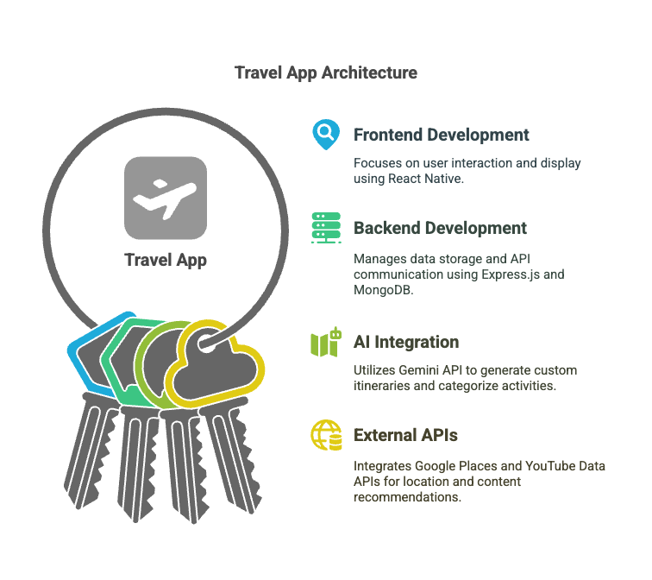Figure 3: App Architecture

1. **FEATURES**

* **Conversational Input**: Users can type casual queries like "I want to go to Goa this weekend."
* **Smart Itinerary Builder**: Day-by-day breakdown with balanced sightseeing, food, and leisure.
* **Restaurant & Attraction Curation**: Filtered based on user interest, time, and distance.
* **YouTube Content Feed**: Watch food tours, city guides, or dos & don’ts before traveling.
* **Save/Share Trips**: Save past plans, export itineraries, or share with travel friends.
* **Scalable Design**: Modular structure to integrate flights, hotel APIs, or calendar sync in the future.

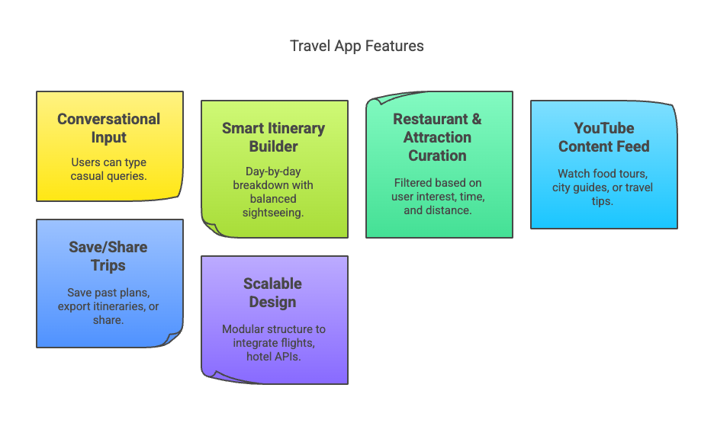Figure 4: Features of the application

* **Data Privacy and Security**

While providing hyper-personalized itineraries and API-driven recommendations, we must ensure travelers’ sensitive information stays protected. In this section you can discuss:

* **User Consent & Data Minimization**

Only collect the minimum fields needed (e.g., destination, dates, preferences).

Explicit opt-in for calendar syncing, location sharing, or video history logging.

* **Secure Transmission & Storage**

All API calls (to Gemini, Google, YouTube Data, etc.) occur over TLS/HTTPS.

User profiles and saved trips in MongoDB Atlas are encrypted at rest (using built-in Atlas encryption).

Access controls via JWT tokens and session ends.

* **Anonymization & Retention Policies**

Remove personally identifiable information (PII) from logs after 30 days.

Aggregate usage analytics (e.g., most popular activities) in an anonymized manner.

* **Compliance & Best Practices**

Compliance with GDPR and CCPA: Data subject to access requests (DSARs), right to be forgotten.

Periodic security audits and third-party penetration tests.

* **Future Enhancements**

Having established the core “AI + API” travel friend, the following enhancements can be phased in to broaden functionality and user delight:

1. Cost Estimation & Budget Planning

* Integrate flight and hotel rate APIs (Skyscanner, Expedia, Airbnb) to surface budget estimates.
* Allow users to set a daily budget and dynamically adjust suggestions (e.g., cheaper eats vs. splurge experiences).

2. Group Trip Coordination

* Shared itineraries: multiple users can collaborate on the same trip plan, vote on activities, and synchronize calendars.
* Conflict resolution: AI assistant handles overlapping constraints (dietary preferences, mobility requirements).

3. Voice & Multimodal Interaction

* Voice prompts powered by Gemini Speech API, enabling hands-free itinerary creation.
* Chat interface for follow-up questions (“What about vegan options in Tokyo?”).

4. Offline Mode & Local Caching

* Pre-download maps, directions, and video clips for use when connectivity is poor.
* Fall back to previously fetched recommendations if the network is unavailable.

5. Social & Gamification Features

* Let users share accomplished itineraries, earn badges, and unlock “hidden gem” recommendations.
* Leaderboards for most-visited cities or most-unique itineraries.

1. **User Personas and Journey Mapping**

### **1. User Persona 1: Casual Traveler – Maya Sharma (Age 27)**

**Occupation**: Marketing Professional  
**Location**: San Francisco, CA  
**Tech Comfort Level**: High  
**Travel Style**: Spontaneous, social media-inspired, solo or with friends

**Background**:  
 Maya is a digital-savvy professional who often plans last-minute weekend getaways to escape her hectic work life. She values experiences over planning and is inspired by travel reels and blog posts. While she loves exploring new cuisines and hidden gems, she often lacks the time or patience to browse endless options and construct an itinerary.

**Goals**:

* Get a complete itinerary in just a few clicks.
* Explore Instagram-worthy spots, local food, and offbeat attractions.
* Get recommendations that feel curated, not generic.

**Pain Points**:

* Too many options on Google and TripAdvisor without clear guidance.
* Dislikes using spreadsheets or calendar apps to plan.
* Prefers casual, conversational tools over form-based planners.

**How “Trip With the Flow” Helps**:  
 With a conversational interface and AI-curated suggestions, Maya simply types “Goa this weekend” and gets a complete plan with restaurant suggestions, video guides, and map integration—no spreadsheets, no stress.

2. **User Persona 2: Group Coordinator – Raj Mehta (Age 35)**

**Occupation**: Product Manager at a Tech Firm  
**Location**: Seattle, WA  
**Tech Comfort Level**: Advanced  
**Travel Style**: Organized, efficient, team-focused

**Background**:  
 Raj frequently coordinates group travel for team-building retreats or family vacations. With differing dietary restrictions, activity preferences, and schedules, planning a unified itinerary is often a nightmare. He values tools that help centralize inputs and reduce friction among group members.

**Goals**:

* Build collaborative, editable itineraries.
* Resolve conflicting preferences using smart recommendations.
* Integrate trip plans with Google Calendar or work tools.

**Pain Points**:

* Manually merging everyone’s preferences is tedious.
* Traditional apps don’t support real-time collaboration.
* Difficult to satisfy everyone's needs (e.g., budget vs. luxury).

**How “Trip With the Flow” Helps**:  
 Raj creates a shared itinerary and invites coworkers. The AI balances “vegan,” “adventure,” and “low-cost” inputs while offering voting features. Gemini resolves conflicts and Raj exports the itinerary to everyone's calendar with a click.

### **3. User Persona 3: Budget Backpacker – Lina Park (Age 22)**

**Occupation**: College Student / Part-time Freelancer  
**Location**: Austin, TX  
**Tech Comfort Level**: Moderate  
**Travel Style**: Low-cost, solo or small group, off-the-grid

**Background**:  
 Lina is an adventurous student who prefers to discover places not listed on mainstream travel sites. She travels on a tight budget, often without consistent internet, and appreciates tools that help her make the most of limited resources.

**Goals**:

* Discover affordable local experiences and street food.
* Access plans offline due to poor connectivity.
* Keep total trip costs under control.

**Pain Points**:

* No centralized way to track daily costs.
* Many apps require constant internet access.
* Recommendations are often biased toward touristy spots.

**How “Trip With the Flow” Helps**:  
 The AI creates a plan with low-cost eateries, hostel suggestions, and public transport tips. Lina can download maps and content for offline use. Budget filters ensure the itinerary matches her spending limits.

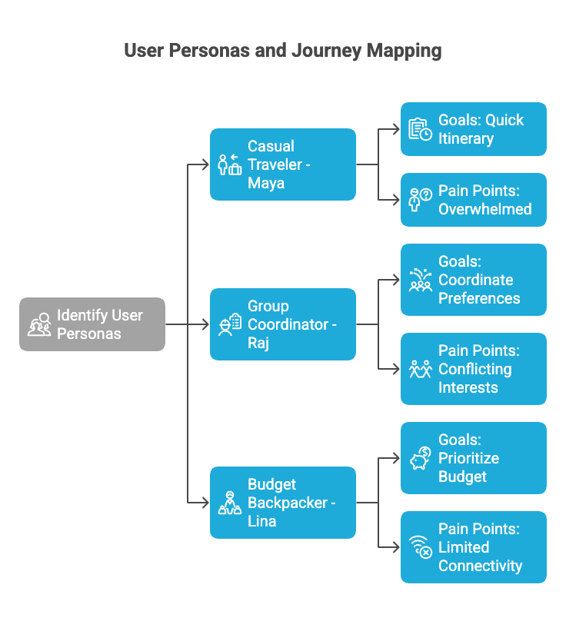Figure 5: User Personas and Journey Mapping

1. **CONCLUSION**

The AI-powered travel assistant presents an innovative approach to solving travel planning issues with artificial intelligence, real-time information feeds, and human-centered interaction. Unlike conventional systems with explicit user input and precomputed results, this application dynamically computes tailored itineraries with a low amount of effort from the user. Using secure, privacy-conscious interactions with the Gemini API as well as external services, the system achieves a prominent level of data confidentiality while providing meaningful suggestions. The solution is applicable for casual tourists as well as corporate trip planners, with evident potential for improvement with group collaboration, cost estimation, voice interaction, as well as offline capabilities. The presented architecture as well as methodology provide a platform for future development in intelligent travel systems that are scalable, secure, and context aware.

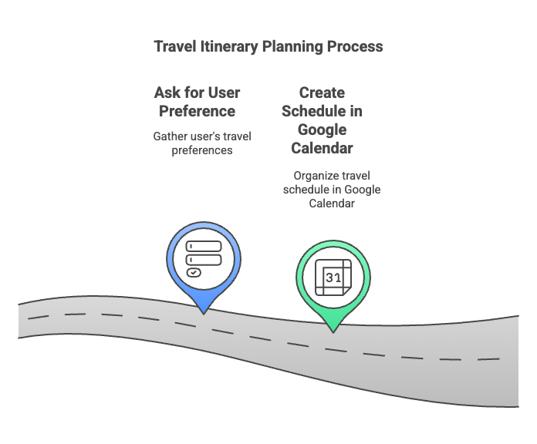Figure 6: Application purpose

1. **REFERENCES**
2. *Google AI. (2024). Gemini API Documentation.* [*https://ai.google.dev*](https://ai.google.dev)
3. *Google Developers. (n.d**.). Google Places API Overview.* [*https://developers.google.com/maps/documentation/places/web-service/overview*](https://developers.google.com/maps/documentation/places/web-service/overview)
4. *Google Developers. (n.d**.). YouTube Data API Overview.* [*https://developers.google.com/youtube/v3*](https://developers.google.com/youtube/v3)
5. *Expo. (n.d.). Expo Documentation.* [*https://docs.expo.dev/*](https://docs.expo.dev/)
6. *MongoDB. (n.d**.). MongoDB Developer Documentation.* [*https://www.mongodb.com/docs/*](https://www.mongodb.com/docs/)
7. *Express.js. (n.d**.). Express - Node.js web application framework.* [*https://expressjs.com/*](https://expressjs.com/)
8. *React Native. (n.d**.). React Native Documentation.* [*https://reactnative.dev/docs/getting-started*](https://reactnative.dev/docs/getting-started)
9. *Travel Itinerary Planner using AI. (2024). [Journal-article]. International Research Journal of Engineering and Technology (IRJET), 11(04), 888.* <https://www.irjet.net/archives/V11/i4/IRJET-V11I4152.pdf>
10. *Manideep, K. V., Atuliya, R., Viswan, V., Ganesh, D. A., Reddy, S. B., Shetty, S., & Dept. of Computer Science and Engineering, (Aiml), Jain (Deemed* *To Be) University. (2024). Trip Planner using Generative AI. In International Journal* *for Multidisciplinary Research (IJFMR) (Vol. 6, Issue 3, pp. 1–2).*
11. **SCREENSHOT**

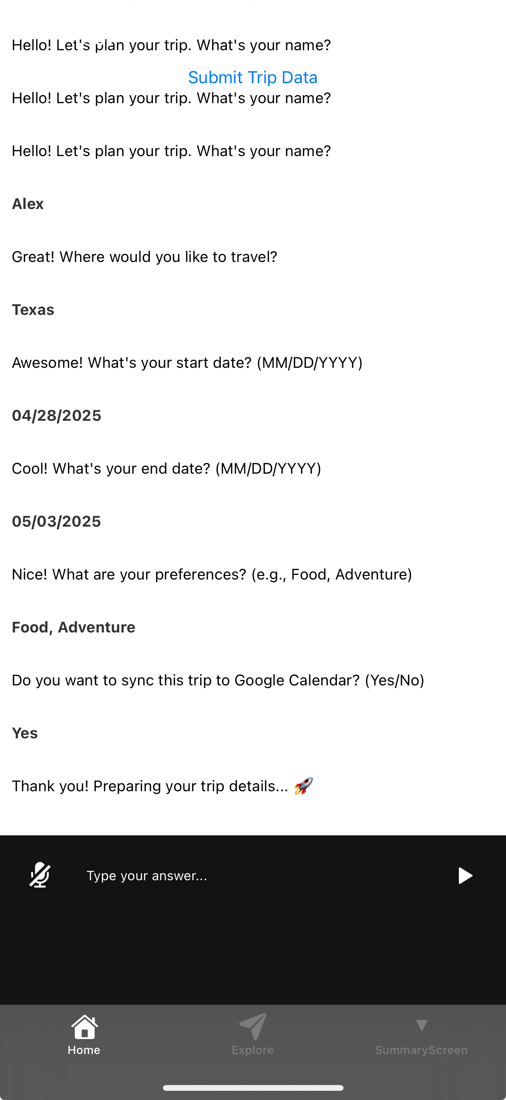Figure 7: User Interface

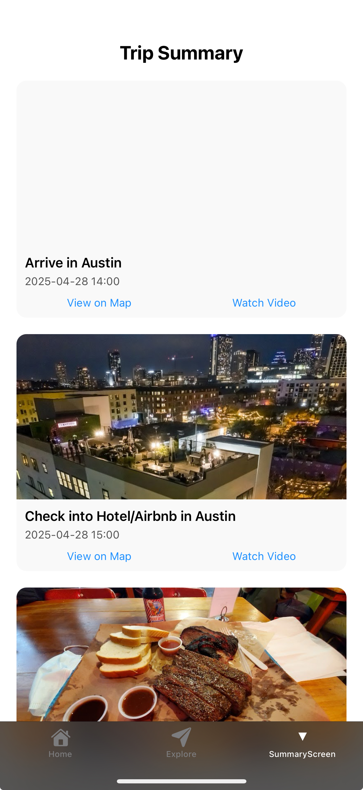

Figure 8: Summary Screen

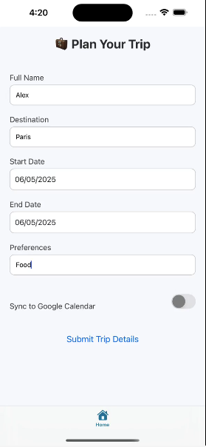

Figure 9: Final User Interface

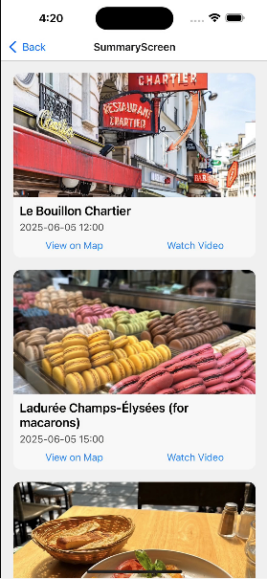

Figure 10: Final Summary Screen



Figure 11: Trips history Screen